
LIBRARY MANAGEMENT
SQL PROJECT
Esha Rawat | 10/5/25

LIBRARY MANAGEMENT

Description: The Library Management System (LMS) database is designed to store, manage, and analyze data related to books, authors, members, borrowings, and other associated information. This structure enables efficient querying, tracking, and data analysis to gain insights into library operations, popular books, member activities, and resource availability.

TABLES IN THE DATABSE
- Books Table – Stores details of each book such as title, author, genre, published year, and available copies.
- Authors Table – Contains information about book authors including their ID, name, and country.
- Members Table – Holds details of library members like name, contact information, and membership date.
- Borrow Table – Tracks borrowing records including which member borrowed which book, along with borrow and return dates.

QUERIES:

CREATING DATABASE:

Question: -Creating Database
Input Query:
Output:
Insight: A separate database is created to manage library operations.

CREATE TABLE:
Question: Create a table of books where there are book id, title, genre, published year, copies available with appropriate constraints
Input Query:
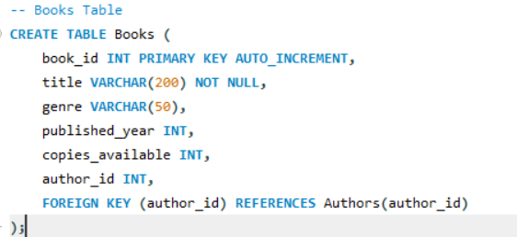
Output:
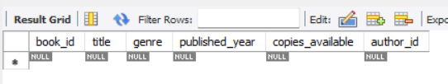
Insight: Ensures unique book ID and stores book details with author id as a foreign key.

INSERTING VALUES:
Question: Inserting values in each column.
Input Query:
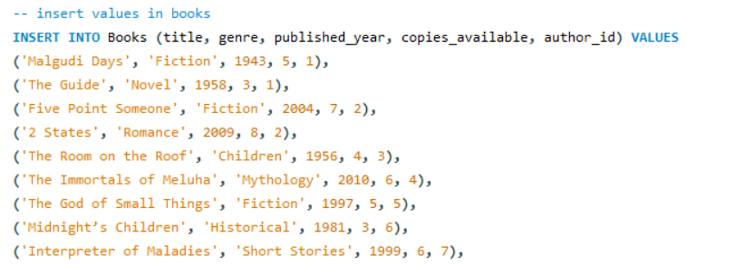
Output:
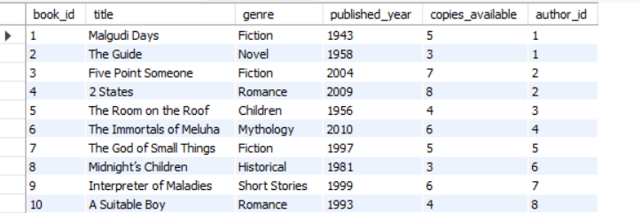
Insight: Data added for testing queries.

ENTITY RELATIONSHIP DIAGRAM:
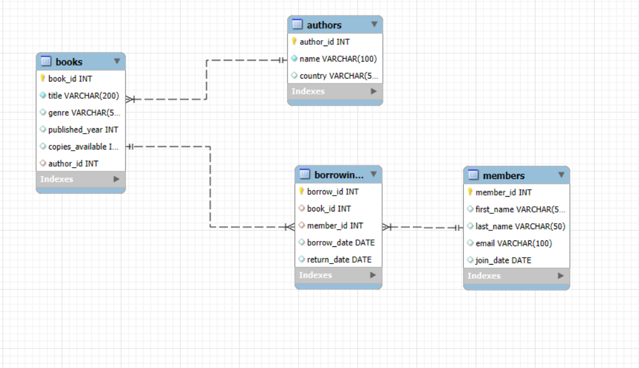

DISABLE SAFE MODE
DISABLE SAFE MODE
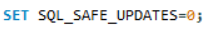
Output:
Update
Question: updating the borrowing table by replacing the year '2025' to null
Input Query
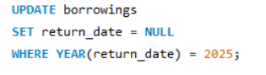
Output:
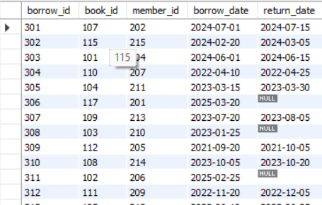
Insight: Demonstrates date manipulation.

AGGREGATE FUNCTION:
Question: finding total members.
Input Query
Output:
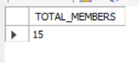
Insight: Counts the total number of registered members in the library.

Question: Finding the Average, Min, Max copies of books available
Input Query
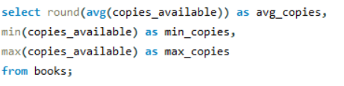
Output
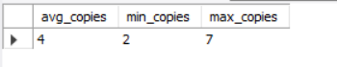
Insight: Shows the average, least, and highest available copies among all books that are useful for stock tracking.

DISTINCT:
Question: find all the unique genre of the books
Input Query
Output:
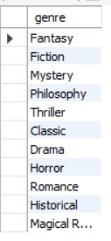
Insight: Finds unique genre allows for analyses.

STRING FUNCTION
Input Query
Output:
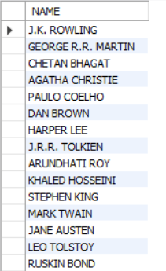
Insight: Converts a ll book titles to uppercase that demonstrates string formatting and can be useful for standardizing text.

DATE FUNCTION
Question: finding the number of years the members have joined membership.
Input Query
Output:
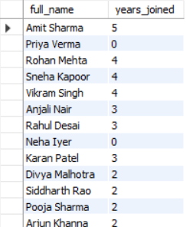
Insight: Calculates how many years each member has been in the library since their membership start date.

Math Functions
Input Query:
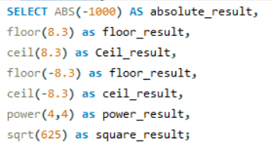
Output:

WHERE CLAUSE
Question: Retrieve all books where the genre is fiction and is released before 2000
Input Query
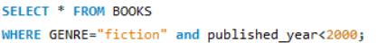
Output
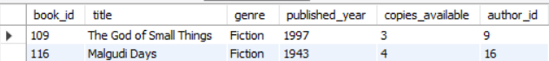
Insight: useful for finding old/classic fiction books.

IN LIST
Question: - Retrieve books that belong to the genre "mystery", "horror", "historical".
Input Query:
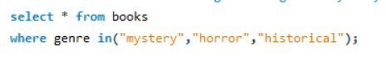
Output:
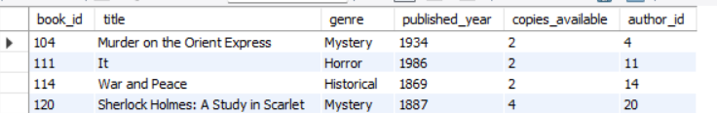
Insight: used when filtering multiple values.

LIKE
Question: -Find all books where the title starts with "the".
Input Query:
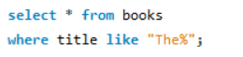
Output:
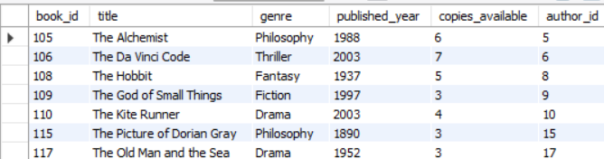
Insight: demonstrates partial text matching.

GROUP BY WITH HAVING:
Question: Retrieving the total books based on genre where the count is greater than 2.
Input Query:
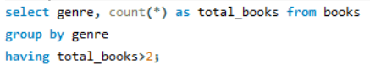
Output:
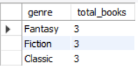
Insights: This helps to identify popular categories of books.

ORDER BY & LIMIT:
Question: finding the latest 5 member that has joined
Input Query:
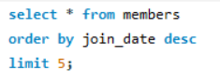
Output:
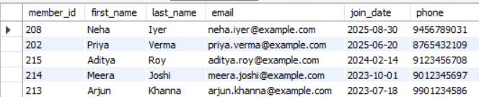
Insight: sorting by members joining date to identify the latest 5 members that have joined.

JOINS:
Question: finding the books published between the year 2000 to 2010
Input Query:
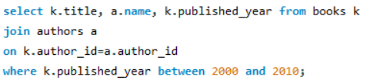
Output
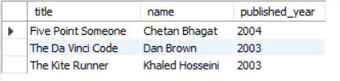
Insights: Helps to analyze books from a specific decade.

Question: retrieving title of books and their authors that belongs to the country “UK”.
Input Query:
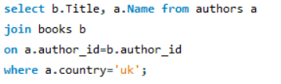
Output:
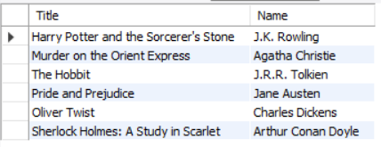
Insights: It helps to filter books based on the author’s nationality.

NESTED JOINS:
Question: Retrieving the information from 3 tables
Input Query:
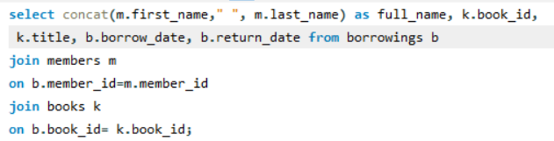
Output:
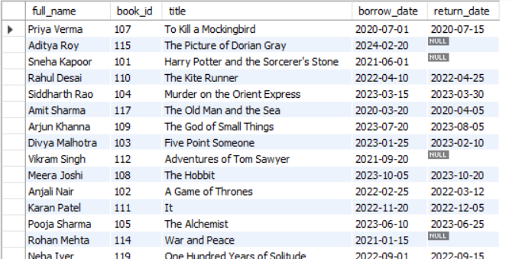
Insights: Combines multiple tables to show title & which member borrowed which book and their return date.

IS NULL / IS NOT NULL
Question: list the member’s name and title where books are currently borrowed and not returned.
Input Query:
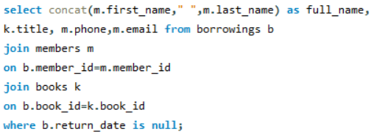
Output:
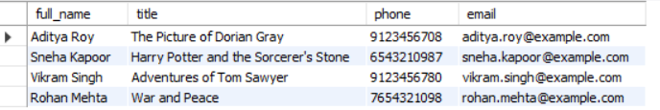
Insight: This query help to analyse which member has not return the book.

Question: calculating which 5 members has kept book for the longest time
Input Query:
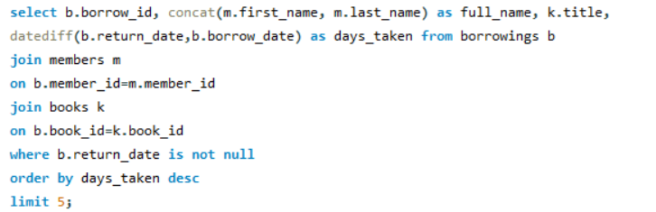
Output:
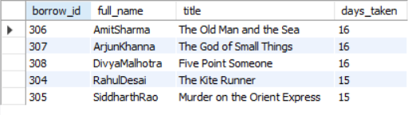
Insights: Useful for monitoring late returns.

SUBQUERIES:
Question: Retrieving the books which has more books copy available than the average.
Input Query:
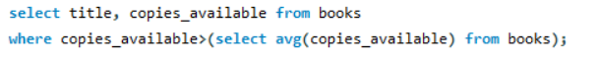
Output:
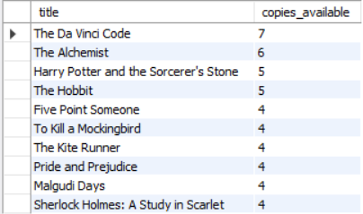
Insight: Retrieves books that have more copies than the average availability.

Question: Find country with the most authors
Input Query:
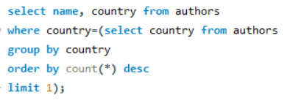

Output:
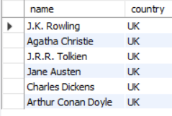
Insight: This query helps to retrieve the country with most authors.

Question: Find the country of the author who wrote the oldest published book.
Input Query:
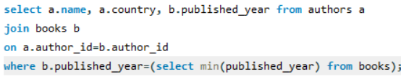
Output:
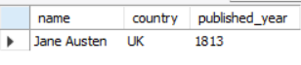
Insights: by combining 2 tables fetching the oldest published book in the database.

WINDOWS FUNCTION:
ROW NUMBER:
Question: Assign row numbers to books by published year.
Input Query:
Output:
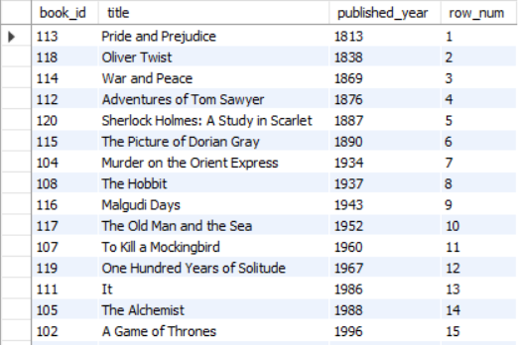
Insight: Gives a unique row number to books ordered by published year.

DENSE_RANK:
Question: Rank books by how recently they were published with DENSE_RANK.
Input Query:
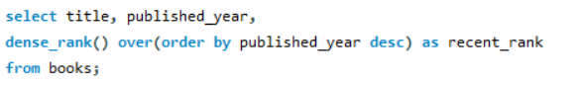
Output
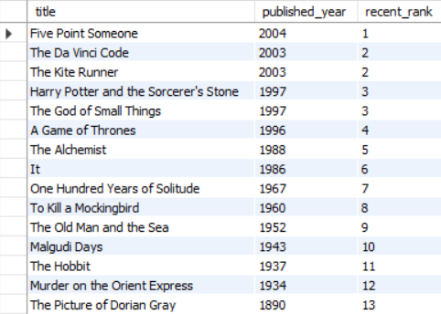
Insight: Ranks books by how recent they are, without skipping numbers for ties.

Question: Rank books by how recently they were published with RANK.
INPUT QUERY:
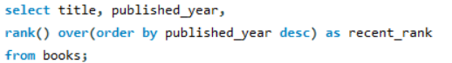
OUTPUT:
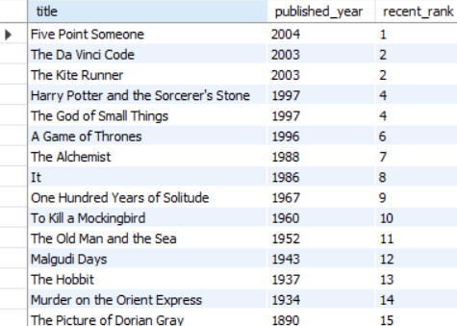
Insight: Similar to DENSE_RANK but skips ranks if multiple books share the same year.

